|  |  |
| --- | --- |
| Description: cee_3line_b_4c_pc_[Converted] | [Description: https://confluence.cornell.edu/download/attachments/10420888/aguaclara_new_logo.jpg](file:///C:\Documents%20and%20Settings\mas352\Desktop\Final%20Designs\DesignSpecs\aguaclara.cee.cornell.edu) |

PRELIMINARY DESIGN FORUI.City UI.State, UI.Country

UI.Name

UI.Organization



June 2, 2014 at 11:00:17 AM

Copyright © 2010 Cornell University

Table of Contents

[Disclaimer 4](#_Toc326145215)

[Permission and Licensing Information 4](#_Toc326145216)

[Introduction to AguaClara 5](#_Toc326145217)

[The sustainable approach 5](#_Toc326145218)

[The treatment process 6](#_Toc326145219)

[The AguaClara Design Tool 7](#_Toc326145220)

[Design Parameters 8](#_Toc326145221)

[Plant Components 9](#_Toc326145222)

[Entrance tank/preliminary sedimentation 9](#_Toc326145223)

[Linear flow orifice meter (LFOM) 11](#_Toc326145224)

[Chemical dose controller (CDC) 12](#_Toc326145225)

[Chemical storage tanks 16](#_Toc326145226)

[Rapid Mix 18](#_Toc326145227)

[Flocculation 19](#_Toc326145228)

[General Flocculator Design 20](#_Toc326145229)

[Inlet Channel 20](#_Toc326145230)

[Sedimentation Tanks 21](#_Toc326145231)

[Assigning dimensions to the sedimentation tank 22](#_Toc326145232)

[Inlet Manifolds 23](#_Toc326145233)

[Sludge drain 25](#_Toc326145234)

[Tolvas 25](#_Toc326145235)

[Plate settlers 25](#_Toc326145236)

[Launders 26](#_Toc326145237)

[Canal de salida 27](#_Toc326145238)

[Chlorine Disinfection 27](#_Toc326145239)

[Manejo de lodos 29](#_Toc326145240)

[Stacked Rapid Sand Filtration: SRSF 29](#_Toc326145241)

[Materials List 32](#_Toc326145242)

[Entrance Tank 32](#_Toc326145243)

[Flocculation Tank 32](#_Toc326145244)

[Sedimentation Tank 32](#_Toc326145245)

[SRSF 32](#_Toc326145246)

|  |  |
| --- | --- |
| Description: cee_3line_b_4c_pc_[Converted] | Description: https://confluence.cornell.edu/download/attachments/10420888/aguaclara_new_logo.jpg  <http://aguaclara.cee.cornell.edu/>  Dr. Monroe Weber-Shirk, Director |

This preliminary design was requested by UI.Name.First UI.Name.Last on behalf of UI.Organization. The design was created on June 2, 2014 at 11:00:17 AM by the AguaClara Design Server at Cornell University. The design is for UI.City UI.State, UI.Country and has a design flow rate of Q.Plant. The design was created with MathCAD code version SVN.Version.

This design is the result of over 20,000 hours of undergraduate, graduate, and faculty labor. The design incorporates advanced fluid dynamics analysis for the hydraulic design to minimize floc breakup between the flocculator and the sedimentation tank. The chemical feed system is based on a series of inventions by the AguaClara team that make it possible to directly set the desired chemical dose and to maintain that dose automatically even as the flow rate through the plant varies. The high rate, shallow sedimentation tank design is optimized for high performance, low cost of construction, and ease of maintenance. The fabrication techniques that make it possible for a single operator to completely disassemble a sedimentation tank while keeping the rest of the plant in operation were developed by the AguaClara team at Cornell and by our partners in Honduras.

The economic value of this design is approximately 10,000 USD. This estimate is based on the amount of time that would be required to create this design if an environmental engineering firm used the AguaClara design algorithms, but not the automated design tool, to create this design. The AguaClara team is committed to continue providing this design service because we want to encourage new implementation partners to explore the use of this technology. We also recognize that high design costs would prevent this technology from being available to small communities. However, we do require funding to maintain our design team and to continue to integrate improvements into our designs. We recommend that implementation partners include a design fee for the AguaClara design service in the project budget. The nominal fee (far below its true value) for use of this design service is 1000 USD per L/s of plant capacity. You are welcome to create multiple designs for each facility that you intend to construct to obtain an optimal plant configuration. This fee, which will guarantee continued technical support from the AguaClara team, can be paid to AguaClara by check or [online to Cornell University](http://sites.google.com/site/cuaguaclara/donate). This fee will likely be between 1% and 2% of the overall project cost for a water treatment plant. Thank you for your support.

##### Donate by Check

Make the check to Cornell University

Write AguaClara in the memo field

Mail to: AguaClara, 220 Hollister Hall, Cornell University, Ithaca, NY 14853

# Disclaimer

This document is a DRAFT. It has not been reviewed for official release. It is included with the design files to show what we plan to deliver in the near future.

This design, including the files accompanying this document, is only a draft and must be reviewed and approved by a licensed engineer prior to construction. If you have questions about this design please contact the AguaClara design team at Cornell University at [CUAguaClara@gmail.com](mailto:CUAguaClara@gmail.com).

### Permission and Licensing Information

Copyright © 2010 Cornell University

Authors: The AguaClara team at Cornell University under the supervision of Dr. Monroe Weber-Shirk

This design was created using the open source engineering services of the AguaClara program at Cornell University. It is subject to the [Creative Commons Attribution-ShareAlike 3.0](http://creativecommons.org/licenses/by-sa/3.0/us/legalcode) United States license. If you alter, transform, or build upon this work, you may distribute the resulting work only under the same, similar or a compatible license.

Permission to use this AguaClara Design Tool along with the subsequent AutoCAD renderings and supporting files for design specifications provided by Cornell based on your input parameters (collectively "WORK") and their associated copyrights without a written agreement is hereby granted. Any water treatment plants built using this WORK shall be designed and supervised by a licensed civil engineer.

IN NO EVENT SHALL CCTEC, CORNELL UNIVERSITY, OR THEIR EMPLOYEES BE LIABLE TO ANY PARTY FOR DIRECT, INDIRECT, SPECIAL, INCIDENTAL, OR CONSEQUENTIAL DAMAGES, INCLUDING LOST PROFITS, ARISING OUT OF THE USE OF WORK AND ITS ASSOCIATED COPYRIGHTS, EVEN IF CCTEC OR CORNELL MAY HAVE BEEN ADVISED OF THE POSSIBILITY OF SUCH DAMAGE.

THE WORK PROVIDED HEREIN IS ON AN "AS IS" BASIS, AND CCTEC, CORNELL, AND THEIR EMPLOYEES HAVE NO OBLIGATION TO PROVIDE MAINTENANCE, SUPPORT, UPDATES, ENHANCEMENTS, OR MODIFICATIONS. CCTEC, CORNELL, AND THEIR EMPLOYEES MAKE NO REPRESENTATIONS AND EXTEND NO WARRANTIES OF ANY KIND, EITHER IMPLIED OR EXPRESSED, INCLUDING, BUT NOT LIMITED TO, THE IMPLIED WARRANTIES OF MERCHANTABILITY OR FITNESS FOR A PARTICULAR PURPOSE, OR THAT THE USE OF WORK AND ITS ASSOCIATED COPYRIGHTS WILL NOT INFRINGE ANY PATENT, TRADEMARK OR OTHER RIGHTS.

Users of WORK shall indemnify, hold harmless and defend Cornell, its officers, employees, agents, and the sponsors of the research that let to WORK against any and all claims, suits, losses, damage, costs, fees, and expenses resulting from or arising out of use of WORK. This indemnification shall include, but not be limited to, any product liability. Users of WORK, at their sole cost and expense, shall sufficiently insure their activities in connection with the WORK and obtain, keep in force, and maintain insurance or an equivalent program of self insurance. Cornell shall notify users of WORK in writing of any claim or suit brought against Cornell in respect of which Cornell intends to invoke the provisions of this paragraph. Users of WORK shall keep Cornell informed on a current basis of its defense of any claims under this paragraph.

# Introduction to AguaClara

## The sustainable approach

AguaClara is a program in Civil and Environmental Engineering at Cornell University that is improving drinking water quality through innovative research, knowledge transfer, open-source engineering, and replicable design of sustainable municipal water treatment systems.

The team is directed by Monroe Weber-Shirk and has worked in partnership with Agua Para el Pueblo, a Honduran NGO specializing in water supply systems, to implement the technologies in rural towns. The AguaClara program received the 2011 Intel Environment Tech Award in recognition of the success of the program in developing sustainable technologies and effective governance models.

Cornell-designed AguaClara municipal water treatment plants are providing six Honduran towns with populations between 1,500 and 15,000 with safe drinking water from their taps. The AguaClara plants produce safe drinking water with turnkey design, construction, operation, training, and transfer costs of $20 to $30 per person served and incremental operating costs of $2-$4 per person per year.

The AguaClara technology is uniquely capable of producing high quality drinking water from turbid surface waters without using electricity. The facilities use gravity powered chemical dosing, hydraulic flocculation (to form large aggregates from the contaminants, or flocs), high-rate sedimentation using custom-fabricated plate settlers (to remove the flocs), stacked rapid sand filtration, and disinfection using liquid chlorine (to kill any residual pathogens that escaped the previous treatment steps). The designs rely on materials that are sourced in the community and national supply chains. The municipal water treatment plants are designed to be easy and economical to operate.

Extending safe drinking water coverage to resource poor communities requires multiple engineering innovations and a new approach to implementation and governance. Our robust technologies do not require electricity or external power sources. Our governance model is based on community ownership, community-based democratic governance, and technologies that are specifically designed to be easy to operate and to encourage pride in ownership. We build implementation partner capacity and intend to encourage the formation of a network of implementation partners that will share best practices for implementation and long-term operation of community-based water treatment facilities.

This integrated model of technology development for compatibility with a sustainable governance model has proven extremely successful. All AguaClara facilities are owned and operated by their respective communities and all facilities continue to provide safe drinking water. This is particularly noteworthy in Honduras where most water treatment plants for large cities do not reliably meet drinking water standards. Several towns with AguaClara facilities are experiencing reverse migration from Tegucigalpa due to their superior water.

Democratic community governance through an elected water board has proven to be very effective and the water boards use the water tariffs (that the community has voted to increase) to fund improvements to their water supply infrastructure. Water boards with AguaClara facilities have invested in reforestation of their watershed, upgrades to their distribution system, extensions to their distribution system to add new customers, and ongoing maintenance of the water supply infrastructure. Customer willingness to pay for safe drinking water is significantly higher than their willingness to pay for unsafe river water and the difference is greater than the increased operation and maintenance cost of providing safe drinking water using AguaClara technologies.

Our goal is to disseminate this technology and our learning regarding sustainable governance globally. The AguaClara engineering designs are shared online to facilitate technology dissemination and to reduce design costs. National engineering firms (non-profit, private, or governmental) are trained to build the water treatment facilities using locally available materials and community labor. Our partners work with locally-trusted organizations to develop a governance model that is suited to the natural resources, national governance framework and available social and human capital of a particular community.

We are seeking funding that will support our research and development work to extend the range of community sizes that can be served using the AguaClara technologies. We have experience with communities between 1,500 and 15,000 and plan to extend that range in both directions. We are researching several technologies that have the potential to reduce the construction and operating costs of the water treatment plants and need funding to support that effort. There are significant engineering and governance challenges as we develop approaches to community based water treatment for communities with fewer than 1,500 inhabitants. Extending our design capabilities for treatment facilities that can serve larger cities is easier. The engineering and technical challenges will require developing new fabrication methods, testing prototypes for performance, and coding the new designs for dissemination via our online design tool.

We are also interested in testing models for implementation and governance. Our experience suggests that partnerships between the AguaClara team at Cornell, implementation partners, and community governance bodies realize their full potential when there is a high level of trust between the organizations and an ongoing technical assistance circuit rider. The AguaClara technologies are designed to encourage the creation of trust and self sufficiency by being easy to understand and easy to maintain even in resource poor communities. We would benefit from experiences with different types of implementation partners and with more governance and technical assistance models to learn which approaches are most effective for various situations.

The AguaClara program overcomes the major barriers to safe drinking water that were previously encountered by small communities. We estimate that well over 100 million people living in Latin America and the Caribbean, Africa, and Asia could benefit from these technologies. The resilient design, innovative fabrication methods based on locally available materials, the automated design tool, and community based governance hold the prospect of improving the quality of life in thousands of communities in the coming years.

## The treatment process

AguaClara plants treat turbidity, pathogens, and natural organic matter using rapid mix, coagulation/flocculation, sedimentation, and rapid sand filtration proceses. The treatment process begins with removal of large debris and preliminary sedimentation of large particles. Then coagulant, which promotes the aggregation of suspended particles, is added to the raw water through a semi-automatic chemical dosing system. The coagulant is mixed with water in a rapid-mix pipe, which delivers macro-scale mixing through minor losses due to pipe configuration, and micro-scale mixing through an orifice plate. The rapid-mix pipe carries the mix of water and chemical coagulant to the flocculation tank, where it is forced through a series of 180 degree turns created by the staggered baffles within. The 180 degree turns ensure sufficient collisions among the suspended particulates to form larger aggregate particles, or flocs.

The flocculated water is then delivered to the bottom of the sedimentation tank through a series of diffusers, which ensure that the flow is directed vertically into the tank. The bottom geometry of the sedimentation tank has been designed to suspend flocs in the middle portion of the tank, creating a floc blanket which itself acts as a filter for other flocs. The top of the tank has a several closely-spaced plates, known as lamella, to shorten the horizontal distance a particle must travel before encountering an obstruction and settling down to the bottom of the tank. The water flowing up from the lamella has been cleaned of most flocs and can then be carried to the stacked rapid sand filter.

AguaClara’s one-of-a-kind stacked rapid sand filter is composed of six sand layers arranged one on top of the other. The water from the sedimentation tank is divided evenly and delivered to every other sand layer by a pipe network. The main pipelines are connected to a series of slotted pipes, which spread the settled water throughout the plan view area of each layer. As water travels through the sand layers, the remaining flocs are captured in the pore space of the sand, and the filtered water is collected by the receiving sand layers (the remaining three layers that did not deliver water into the filter). A siphon system and pipe stubs that vary the water outlet elevations enable the filter to self-backwash, minimizing demand on the operator.

The final step in the AguaClara water treatment process is disinfection. The semi-automatic chemical doser delivers chlorine to the filtered water. The chlorinated water is stored in a distribution tank to allow for sufficient contact time with the chemical, ensuring the water is fully disinfected. After disinfection, the treated water is ready for distribution to households. Water treated by the AguaClara system is consistently below 5 nephelometric turbidity units (NTU), and frequently meets the US standard for maximum turbidity, 0.3 NTU.

## The AguaClara Design Tool

In the AguaClara Design Tool (ADT), the basic design parameters requested (e.g. flow rate, wall thickness, number of sedimentation tanks desired, the dimensions of purchased lamella material, etc.) are used as variables in a series of hydraulic and geometric algorithms that define the dimensions of the plant reactors and their accessories. The design algorithms in the ADT are based on fundamental physics, and thus are scalable over a wide flow range. Algorithms have been revised and constrained based on lab research and feedback from the field to ensure both efficient material usage and ease of operation. The software output based on these parametric algorithms is a three-dimensional drawing in AutoCAD of each reactor that is to be given to the designer. The designer completes the design based on the ADT output by adding the final treatment components, the plant building, and distribution system, and then the designer must perform a full structural analysis of the plant. This document provides a summary of AguaClara processes with regard to the design of closed facilities. Consequently, all calculated values (e.g. lengths of plant reactors, distances between the centers of the orifices, etc.) are specific to this plant design, and do not necessarily apply to other AguaClara plants.

# Design Parameters

Included is the design for a plant for UI.City having a maximum flow rate of Q.Plant L/s. The design was created assuming specific input parameters, shown in Table 1 below. The software uses these parameters together with the requested flow rate as variables in a series of hydraulic and geometric calculations that define the dimensions of the various plant components. The goal of the plant with respect to water quality is to reduce the turbidity as much as possible and to have it meet international water quality standards (less than 5 NTU), maintain the color within norms (15 Unidades de Color – UC), disinfect the water with chlorine, and maintain a residual chlorine concentration throughout distribution between 0.3 and 1.0 mg/L. The plant treats water without using electricity, utilizing preliminary sedimentation, flow control, rapid mix, coagulation/flocculation, hydraulic upflow sedimentation, filtration, and chlorination.

|  |  |  |
| --- | --- | --- |
| ***Maximum flow rate*** | Q.Plant | |
| ***Geometric Assumptions*** | | |
| Thickness of the plant walls | T.PlantWall | |
| Minimum concrete thickness | T.ConcreteMin | |
| Minimum tank dimension for construction worker to fit inside | W.HumanMin | |
| Minimum height from bottom of drain channel to top of walkway so that operator can fit inside | H.HumanAccess | |
| Minimum width of a channel for constructability | W.ChannelMin | |
| Plant freeboard height | H.PlantFreeboard | |
| *Entrance Tank* | | |
| Maximum hopper angle | AN.EtSlope | |
| Maximum upflow velocity | V.EtUp | |
| Maximum water height for ease of operation | HW.EtMax | |
| Thickness of the ledge between hoppers | T.EtLedge | |
| *Chemical Dosing* | | |
| Turnover time for the chemical stock | Ti.CoagStock | |
| Height of the chemical tanks above the constant head tanks | H.CoagTankAboveHeadTank | |
| Minor loss coefficient for small diameter tubing | K.CdcTube | |
|  | Coagulant | Chlorine |
| Maximum dose | C.CoagDoseMax | C.ChlorineDoseMax |
| Maximum stock concentration | C.CoagStockMax | C.ChlorineStockMax |
| Maximum head loss through small-diameter tubing | HL.CoagCdc | HL.ChlorCdc |
| *Flocculation* | | |
| Minor loss coefficient for flow around a baffle | K.FlocBaffle | |
| Desired collision potential | CP.Floc | |
| Desired energy dissipation rate | ED.Floc | |
| Maximum time required to drain the tank | Ti.FlocDrain | |
| *Sedimentation* | | |
| Angle of side slopes | AN.SedSlope | |
| Angle of plate settlers | AN.SedPlate | |
| Angle of floc hopper slopes | AN.SedHopperSlope | |
| Minimum spacing between plate settlers | S.SedPlateMin | |
| Upflow velocity | V.SedUpBod | |
| Capture velocity | V.SedCBod | |
| *Stacked Rapid Sand Filter* | | |
| Wall thickness | T.FiWall | |
| Backwash velocity | V.FiBw | |
| Number of sand layers | N.FiLayer | |
| Time required to drain backwash water above fluidized bed | T.FiBwInitiationBod | |
|  |  | |
| *Material Dimensions* | | |
| Width of plate settler material | W.SedPlate | |
| Length of plate settler material | L.SedPlateSheet | |
| Thickness of plate settler material | T.SedPlate | |

Table 1. Automated Design Tool assumptions used to calculate the included design.

The treatment processes – preliminary sedimentation, coagulation, flow control, rapid mix, EN.FlocType hydraulic flocculation, hydraulic upflow sedimentation, filtration, and chlorination – have been designed according to the maximum flow rate, Q.Plant L/s. While the resulting dimensions and layout have been cost optimized wherever possible, the user may choose to change some calculated values, such as those given in Table 2, to alter the plan view area of the plant for specific site requirements.

|  |  |
| --- | --- |
| Number of sedimentation tanks | N.SedTanks |
| Number of sedimentation bays per tank | N.SedBays |
| Flocculator depth | H.Floc |
| Flocculator type | EN.FlocType |

Table 2. Calculated values for UI.City, UI.Country that may be altered to produce optimized plan view areas for site-specific constraints.

# Plant Components

## Entrance tank/preliminary sedimentation

The main functions of the entrance tank are to remove solids from the water through preliminary sedimentation, to measure the flow through the plant, and to provide a place where the quality of the raw water can be observed. The preliminary sedimentation process removes solids such as sand, silt, and clay from the water before applying the coagulant to the influent. Water enters the plant on the right side of the entrance tank shown in Figure 1 and flows linearly over the top of the inverted pyramidal traps, or hoppers, at the bottom of the tank. The first hopper contains an overflow weir pipe to waste any water entering the plant in excess of the plant flow rate. The overflow pipe has a nominal diameter of ND.EtOverflowDrain, sized to handle half of the total plant flow rate. A slot is cut from the pipe such that 10% of the vertical dimension of the pipe is lost, giving a W.EtOverflowSlot wide opening, starting at a height of H.EtOverflowCutaway below the natural inner diameter of the pipe. The length of the slot is designed to fit along the length of the first hopper, giving an effective weir length (two times the slot length) of L.EtOverflowWeir. A drain is also embedded into the first hopper, allowing the operator to manually adjust the plant flow rate by opening the flow control valve by a desired amount, wasting water into the channel below. The ND.EtFlowControl nominal diameter drain is designed to handle the drain the full plant flow rate if needed.

Large particulates settle out into the hoppers, and collect near the drains at the bottom. When the water reaches the end of the tank, it flows through the orifices of the riser pipe, which acts as a linear flow orifice meter (LFOM). It is designed for a capture velocity of W.EtCapture to remove these particulates. A length of L.Et is assigned to the entrance tank to correspond to the sedimentation tank length plus enough space to fit the float of the chemical dose controller and the rapid mix pipes. The width, W.Et, is then assigned to ensure the minimum desired capture velocity is met while still allowing enough space for a person to fit inside and construct the tank. The depth of the tank is then determined such that the velocity in the upper rectangular portion of the tank does not exceed the velocity in the flocculator, V.Floc, while ensuring the depth is sufficiently small that the drains are easy to access. In this case, the tank has a height of H.Et.

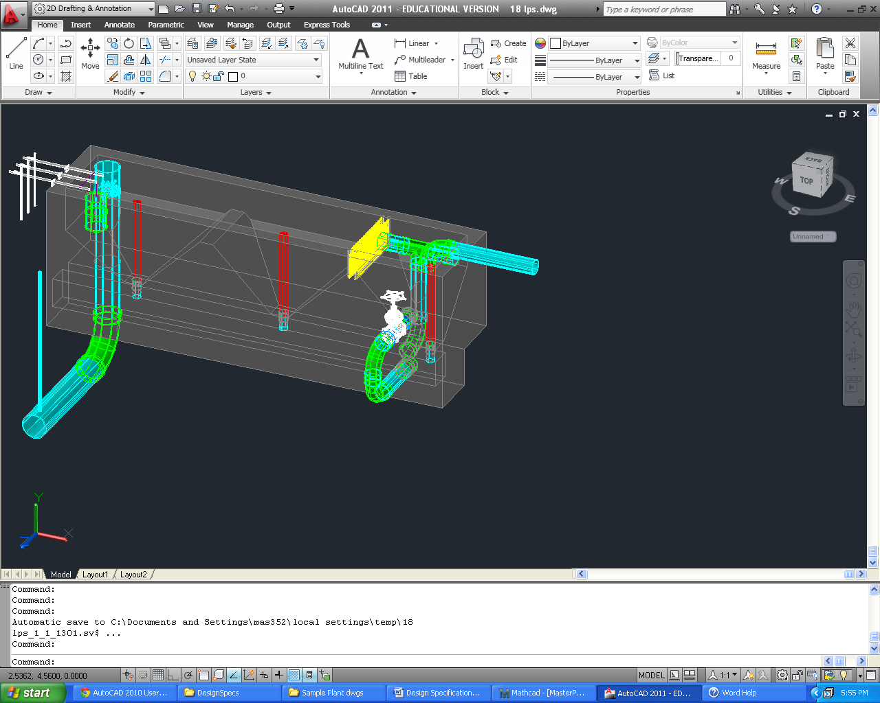

inlet pipe

linear flow orifice meter

overflow weir pipe

trash racks

flow control valve

chemical dose controllers

rapid mix pipe

air removal pipe

hopper stops

Figure . A sample entrance tank for an 18 L/s plant. Water enters the tank through the inlet pipe shown at the right. Water flows linearly over the hoppers to the end of the tank, where it flows into the orifices of the linear flow orifice meter, and then on to the flocculator.

To allow for easy maintenance, N.EtHoppers hoppers must be built into the entrance tank, at an angle of AN.EtSlope, forcing sediments to slide to the bottom where the ND.EtDrain drains are located. When too much sediment has accumulated, the upper drain pipes must be removed until the sludge is flushed out. Directly below the entrance tank, there is a drain channel to collect the waste.

As the raw water flows from the first hopper to the subsequent ones, it must pass through two trash racks, preventing large debris from entering the treatment process. Having two trash racks allows the plant to run with a grit screen even while the operator cleans one of them. The trash racks are made of rebar and slide into two slots built into the entrance tank wall. The center-to-center distance between the rebar, B.EtRebar m, is set to ensure that debris large enough to clog the orifices in the linear flow orifice meter downstream (LFOM) are kept out.

Suspended particulates in the water settle out over the length of the entrance tank into the hoppers below. When enough sludge has accumulated at the bottom, the hopper stops can be removed to flush out the debris down into the drain channel below, and they can then be replaced to resume normal operation. The ND.EtDrain in nominal diameter hopper stop is L.EtDrainStopper m long, ensuring the top of the pipe is above the maximum water height in the tank. Table 3 summarizes the entrance tank design specifications below.

|  |  |
| --- | --- |
| *Entrance Tank* | |
| Residence time |  |
| Capture velocity |  |
| Tank length | L.Et |
| Tank width | W.Et |
| Tank height | H.Et |
| Hopper length | L.EtHopper |
| Hopper height | H.EtHopper |
| Last slope height | H.EtLastSlope |
| Hopper side slope angle | AN.EtSlope |
| Hopper back slope angle |  |
| Thickness of ledge between hoppers | T.EtHopperLedge |
| Number of full hoppers | N.EtFullHopper |
| *Hopper Drains* | |
| Hopper drain diameter | ND.EtDrain |
| Hopper stop length | L.EtDrainStopper |
| *Flow Control Components* | |
| Flow control valve diameter | ND.EtFlowControl |
| Overflow weir pipe diameter | ND.EtOverflowDrain |
| Overflow weir pipe slot length |  |
| Overflow weir slot depth |  |
| *Trash Rack* | |
| Trash rack rebar spacing |  |
| Trash rack rebar diameter  Table . Entrance tank characteristics for UI.City. |  |

## 

## Linear flow orifice meter (LFOM)

The linear flow orifice meter, or LFOM, is the riser pipe found in the leftmost hopper of the entrance tank. Water exits the entrance tank through the orifices in the LFOM, is dosed with coagulant, undergoes rapid mix, and then enters the flocculation tank. The diameter of the pipe is set such that cross-sectional area of the pipe required is Pi.LfomSafety times the minimum area required to carry the average velocity of water in the pipe, giving a ND.RMPipe in nominal diameter pipe. The additional area ensures that water free falls into the rapid mix pipe so the flow in the pipe is hydraulically disconnected from the flow through the entrance tank. The orifice pattern in the LFOM is designed to approximate the shape of a sutro weir, which forces a linear relationship between the flow rate over the weir and the head loss over the weir. The maximum head loss over the weir is set to be HL.Flowmeasure m, since the sutro weir approximation is not valid at higher head losses. Assuming a B.LfomRows m spacing between the rows of orifices, the theoretical flow area required in the top B.LfomRows m of the LFOM can be calculated, and the orifice size is set to be no larger than that to ensure at least one orifice can be placed in the top row. This design requires D.LfomOrifices m diameter orifices. The number of orifices in each row is calculated by minimizing the mean square error as compared to perfectly linearized flow. Table 4 gives the orifice pattern for this specific design.

|  |  |
| --- | --- |
| **Row Height (m)** | **Number of Orifices** |
| H.LfomOrifice1 | N.LfomOrifices1 |
| H.LfomOrifice2 | N.LfomOrifices2 |
| H.LfomOrifice3 | N.LfomOrifices3 |
| H.LfomOrifice4 | N.LfomOrifices4 |
| H.LfomOrifice5 | N.LfomOrifices5 |
| H.LfomOrifice6 | N.LfomOrifices6 |
| H.LfomOrifice7 | N.LfomOrifices7 |
| H.LfomOrifice8 | N.LfomOrifices8 |
| H.LfomOrifice9 | N.LfomOrifices9 |
| H.LfomOrifice10  Table . The orifice pattern in the LFOM for UI.City. The row height is measured from the bottom of the orifices in the first row. | N.LfomOrifices10 |

## Chemical dose controller (CDC)

The chemical dose controller (CDC) doses raw water with coagulant (????? In India??) and filtered water with calcium hypochlorite for disinfection. The CDC is hydraulically connected to the entrance tank, enabling the control system to automatically adjust the flow of chemical solution through the plant to maintain the desired dose at even varying flow rates. As pictured in Figure 2, a ND.EtFloat diameter pipe float hangs from the dosing lever arm and sits in the last hopper of the entrance tank. The left side of the lever arm is marked with a dosing scale and has a drop tube attached to a slider. The operator moves the slider along the left side of the arm to set the desired dose. The chemical is administered to the drop tube from constant head tanks using a set of small diameter, straight, long ‘dosing’ tubes that control flow. The constant head tank is fed through a tube connected to the stock tanks. The flow of chemical from the stock tanks is controlled using a float valve, which maintains the desired fluid reference level in the constant head tanks. The plant geometry is such that a double lever arm connects the entrance tank float to the chlorine and coagulant stock tanks, thus enabling the operator to control dosing of both chemicals from a single location.

Figure . The chemical dosing center for an 18 L/s plant. The dosing lever arm is mounted to the left side of the entrance tank, and the constant head tanks are mounted on the east wall of the chemical stock tank platform.



float

chemical calibration columns

dosing arms with scales

constant head tanks

chemical stock tank drains

chemical stock tanks

### CDC: Design Specifications

Table 5 lists the complete specifications for the dose controllers.

|  |  |  |
| --- | --- | --- |
| **Chemical Dose Controller Specifications** | | |
| ***General parameters*** | | |
| Coagulant Type | EN.Coag | |
| ***Chemical Concentrations*** | | |
|  | *Filter coagulant* | *Chlorine* |
| Maximum Dose | C.FilterCoagDoseMax | C.ChlorineDoseMax |
| Maximum Stock Concentration | C.FiCoagStock | C.ChlorineStockMax |
| ***Tanks and Floats*** | | |
| ET Float diameter | ND.EtFloat | |
| ET Float height | L.EtFloat | |
|  | *Filter Coagulant* | *Chlorine* |
| Float valve orifice diameter | D.FilterCoagFloatValveOrifice | D.ChlorFloatValveOrifice |
| Stock tank to constant head tank tube diameter | D.FilterCoagTubeStockToCH | D.ChlorTubeStockToCH |
| Large tube diameter (see CDC Design Alg.) | ??????????? | ??????????? |
| ***Lever Arm and Drop Tube*** | | |
| Lever arm length (total) | L.LeverArmTotal | |
| Float Arm Length | L.CdcFloatArm | |
| Scale Arm Length | L.CdcScaleArm | |
| Drop Tube Length | L.DropTube | |
| Drop Tube Diameter | ND.DropTube | |
| ***Dosing Tubes for Flow Control*** | | |
| Minor loss coefficient | K.CdcTube | |
|  | *Filter Coagulant* | *Chlorine* |
| Number of Tubes | N.FiCoagCdcTubes | N.CdcChlorineTubes |
| Length of Tubes | L.FiCoagCdcTube | L.CdcChlorineTube |
| Diameter of Tubes | D. CdcFiCoag | D.CdcChlorine |
| Maximum head loss through small-diameter tubing | HL.CdcCoag | HL.CdcChlorine |

Table 5. Chemical dose controller design for UI.City.

### CDC: Calibration and Operation

For the doser to function optimally, it is crucial for each component to be installed correctly. To properly calibrate the doser once it has been mounted to the entrance tank, the no flow situation needs to be simulated in the entrance tank (Figure 3) by draining the tank until its water level is just below the bottom of the LFOM’s bottommost row of orifices. Then, with the lever arm perfectly horizontal, adjust the length of the rope attached to the float so that the float sits exactly vertically. With the lever arm in the horizontal position, mount the constant head tank such that its fluid level is at the same elevation as the dosing point. Then, fill the entrance tank until the water height corresponds to the maximum flow rate (where the topmost orifices of the LFOM are just submerged, as in Figure 4). The elevation of the maximum dose point on the scale should have decreased by the maximum allowable head loss for the chemical. Position the slider to an intermediate dose. (It is important to calibrate the doser at an intermediate dose – as in Figure 5 – because this method leaves extreme flow rates less susceptible to calibration errors.) At the intermediate dosing position, measure the flow of chemical through the dosing tube and compare it to the theoretical flow rate, which can be calculated by rearranging Eq 2 as follows:

Eq 7.

Figure . Chemical dose controller configuration in “no flow” mode. The yellow line delineates the water level in the entrance tank (just below the bottommost row of orifices in the LFOM), and the orange line delineates the stock chemical solution level in the constant head tanks. In no flow mode, the fluid level elevation in the constant head tanks is same as that of the dosing point, meaning there will be no flow of chemical into the plant.



lever arm

slider

constant head tank

float

drop tube

weight

dosing tube

LFOM pipe

where hf is given by the elevation difference between the dosing point and the fluid level in the constant head tank. If the flow rate is greater than the theoretical, cut the tube and repeat the test until the theoretical value matches the measured value. If the flow rate is less than the theoretical, a longer tube must be obtained and the calibration must begin again from the first step. Once the theoretical and measured values match, the doser is ready for use.



Figure . Chemical dose controller configuration in operating mode. The yellow line delineates the water level in the entrance tank; in this case the water level is at its maximum and the plant is running at full capacity. The orange arrow represents the driving head for the chemical stock solution, given by the elevation difference between the fluid level in the constant head tank and the dosing point. Note that the slider is at the maximum dose point.

In addition to good calibration, the doser must be periodically cleaned for good performance. Any sediment that may be clogging the valves or fittings must be cleaned out to prevent underdosing. Additionally, air bubbles in the tubes will cause dosing errors. If bubbles are present, remove the tube from the dosing system and force the bubbles out.

When there is no flow through the plant, as shown in Figure 3, the dosing arm is level, and there is no head to drive the flow of chemical. When water is flowing through the plant, the float rises along with the water level in the tank, dropping the dosing point below the elevation of the fluid level in the constant head tank, and thus providing a driving head for chemical flow. This situation is pictured in Figure 4. To decrease the chemical dose, the operator needs to move the slider to the desired dose marked on the scale of the level arm. With the slider moved further to the right, the dosing point elevation does not decrease as much as the float rises, and so the driving head – and thus the chemical flow – decreases. This situation is pictured in Figure 5.



Figure . Chemical dose controller configuration in operating mode. The yellow line delineates the water level in the entrance tank; in this case the water level is at its maximum and the plant is running at full capacity. The orange arrow represents the driving head for the chemical stock solution, given by the elevation difference between the fluid level in the constant head tank and the dosing point. Note that the slider is at an intermediate dose point, resulting in less driving head for the chemical and thus a lower fluid flow rate.

### CDC: Design Algorithm (DELETE???)

The following sections gives an outline of the methods used to design the CDC, which might be useful when troubleshooting the apparatus.

Recall that the water height in the entrance tank changes linearly with the flow rate going through the plant due to the LFOM. Similarly, the flow of chemical stock solution is linearly related to the elevation difference between the fluid level in the constant head tanks and the dosing point. The linear relationship between the driving head of the chemical and the chemical flow rate is established by designing the dosing tubes such that the head loss is dominated by major (shear) losses. The lengths of the dosing tubes are limited by the need to have the tubes drape without hitting the floor. The tubes must hang freely and have space for a weight to keep the tube as straight as possible, minimizing additional losses that would cause errors in the flow calculation. Moreover, the tubes cannot be too short, or else the number of tubes required to supply the needed flow gets high, and the apparatus gets complicated. To determine the best combination of lengths and numbers of tubes, we need to first determine the possible flow rates available from purchasable tubing diameters. Allowing no more than a ΠLinearCdcError = 10% deviation from the desired linear flow relationship due to minor losses, the flow rate, QAvailable, through each available tube size is calculated as given in Eq 1 below.

Eq 1.

The diameter of the tube is D, the maximum headloss through the dosing system is HLCdc, g is the gravitation constant, and KCdcTube = K.CdcTube is the minor loss coefficient for the tube.

Modifying the Hagen-Poiseuille equation for the length of a tube, given major head loss hf, tube diameter, fluid viscosity ν, and fluid flow rate (Eq 2), the required length LCdcTube of each tube to obtain the desired head loss at maximum flow may then be calculated for each available flow rate (Eq 4).

Eq 2.

Eq 3.

Eq 4.

When the length of the tube is being calculated, the true viscosity of the fluid is unknown, and so the viscosity of the maximum stock solution is assumed for the case of the coagulant. The viscosity of chlorine is assumed to be that of water since the solution must be sufficiently dilute to produce simple designs.

Once all possible lengths for each diameter have been calculated, the algorithm chooses the longest tube and associated diameter that is smaller than the maximum length to ensure draping. This decision minimizes the number of tubes, keeping the doser as simple as possible. At this point, the number of dosing tubes NCdcTubes assuming the maximum chemical stock concentration CChemStockMax can be calculated as follows in Eq 5:

Eq 5.

where QPlant is the maximum plant flow rate, CMaxDose is the maximum allowable dose, and QTube is the flow rate through the design tube.

Finally, the required chemical stock concentration can be specified based on the calculation in Eq 6.

Eq 6.

In the event that the required tube length is not long enough to reach from the constant head tank to the drop tube, the small-diameter design tube may be linked to a larger diameter tube just long enough to reach the dosing point. If a large diameter tube is required for a particular chemical, its length is indicated in Table 5

## Chemical storage tanks (What do we require here?)

There are two to four storage tanks for each chemical on the stock tank platform – two for the main plant coagulant, two for chlorine disinfection, and optionally two for coagulant dosing before filtration, as shown in Figure 6. The stock tanks are set at an elevation of Z.CoagTank to provide enough head to overcome minor losses in the system, ensuring the desired flow rate can be attained. The design of the chemical storage tanks is based on the tank volumes available for purchase through Rotoplast for Latin America, and it is assumed that the stock tank will be refilled no more frequently than once every Ti.StockMin. In order to determine the required volume of a chemical tank, the maximum chemical flow rate, QChemStockMax, must first be determined as follows:



Figure . Chemical stock tanks for an 18 L/s plant.

Eq 8

where CChemDoseMax is the maximum allowable chemical dose, and CChemStock is the stock concentration in the chemical tank. Using the maximum chemical flow rate, the volume of the stock tank, VolChemTank, is computed using the following formula:

Eq 9

For plants that require stock tank volumes slightly larger than the nearest available tank volume, the ADT automatically rounds down to the nearest desired volume to make the size as small as possible. Specifications for this particular stock tank design are given in Table 6 below.

|  |  |
| --- | --- |
| **Stock Tank Specifications** | |
| Turnover time for the chemical stock | Ti.CoagStock |
| Height of the chemical tanks above the constant head tanks | H.CoagTankAboveHeadTank |
| Dose and drain plumbing size | ND.CoagPiping |
| Coagulant tank volume | Vol.CoagTank |
| Chlorine tank volume | Vol.ChlorineTank |
| Filter coagulant tank volume | Vol.FiCoagTank |
| Height of stock tanks above constant head tanks | H.CoagTankAboveHeadTank |

Table 6. Chemical storage tank design for UI.City.

All of the piping required to administer the dose and drain the stock tanks (Figure 7) uses a nominal diameter of ND.CoagPiping. The piping that connects to the constant head tanks begin at a bulkhead fitting set at an elevation of B.StockOutlet higher than the bottom of the stock tanks to prevent sediment from entering the pipes. The flow is controlled at the top of the stock tank platform using a ball valve, and the plumbing continues down through the platform, and out through the wall facing the entrance tank at the approximate elevation of the constant head tanks. The stock tank drains are connected from the bottom center of the tanks, starting with a male insert, and continuing under the platform and exiting via ball valve at the edge of the main plant drain channel. Figure 8 shows more close up details of the dosing and chemical drain plumbing.

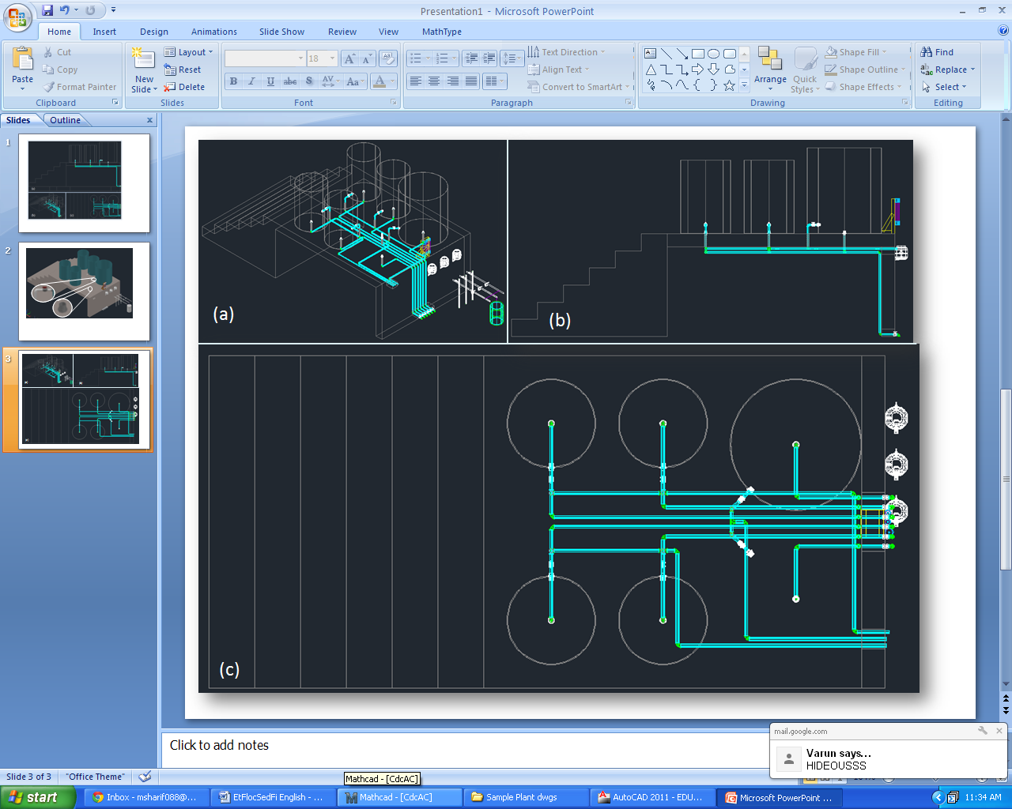

Figure . Southeast isometric (a), front (b), and top (c) views of the chemical stock tanks for an 18 L/s plant with a main plant coagulant tank left out for a clearer view of the piping.

Figure . 18 L/s plant with a main plant coagulant tank left out for a clearer view of the piping. The dosing plumbing (a) is connected to the stock tanks via bulkhead fitting and the flow is controlled using a ball valve. A male insert (b) is affixed to the bottom of the stock tanks, ultimately leading to ball valves (c) that sit at the edge of the main plant drain channel.

## Rapid Mix (WHATS THE PROCESS IN INDIA?)

Once it has been dosed with coagulant, the water passes through the rapid mix system. Rapid mix serves to uniformly distribute the coagulant through the raw water. In this plant, the rapid mix occurs as turbulent flow through a L.RMPipe long pipe, with an inner diameter of ND.RMPipe. This pipe brings water from the point at which coagulant is dosed to the entrance of the flocculator.

## Stacked Rapid Sand Filtration: SRSF

|  |  |  |
| --- | --- | --- |
| Number of Filters | N.Fi | |
| Wall Thickness | T.FiWall | |
| Flow through single Filter | Q.Fi | |
| Bottom Elevation | Z.FiBottom | |
| *Sand* | | |
| Number of Filter Layers | N.FiLayer | |
| Height of Filter Layers | H.FiLayer | |
| Height of Bottommost Layer | H.FiBottomLayer | |
| Height of Sand | H.FiSand | |
| d60 | D.FiSand60 | |
| Porosity | Porosity.Sand | |
| *Trunk Lines* | | |
| Main Trunk Diameter | ND.FiTrunk | |
| Backwash Trunk Diameter | ND.FiBwTrunk | |
| *Branches* | | |
|  | Main Layers | Backwash Layer |
| Branch Diameter | ND.FiManBranch | ND.FiBwManBranch |
| Slot Spacing | B.FiManSlot | B.FiBwManSlot |
|  |  |  |

Las plantas de AguaClara cuentan con un sistema de filtración no convencional. Comúnmente, solamente plantas de grandes caudales pueden permitirse la incorporación de un filtro de arena. Los filtros de arena convencionales usan grandes cantidades de agua limpia para el retrolavado, electricidad, y son de construcción y mantenimiento complejo, incluyendo varias válvulas y piezas que se rompen con facilidad y son difíciles de reponer.

Por estas razones, el equipo de AguaClara ha diseñado un filtro con unas restricciones de diseño que no use electricidad, evite el uso de válvulas y piezas caras y de difícil obtención, que use poca agua, que cada parte del filtro sea visible y accesible para el operador, y que sea de fácil manejo.

Usando los principios de perdida de cabeza y aprovechando las diferencias de altura del agua, el equipo de AguaClara creo un diseño de tres filtros de arena en uno (FRAMCa). Este diseño reduce la cantidad de agua que se necesita, y gracias a su tamaño compacto y sencillo, una planta de relativamente poco flujo puede contar con tres filtros de arena.

Filtration begins once the settled water leaves the sedimentation tank. To ensure the filter functions optimally, the water must be sufficiently treated at the start of the process to a low turbidity. The filter must be washed regularly to liberate particulates trapped in the void space of the filter media. Once the water leaves the filter, it is sent to a distribution tank where chlorine is applied to destroy the last of the particulates.



Figure 18. ( Left) Top view of the sedimentation tank and a single filter below it. (Right) Isometric view of the filtration unit and sedimentation tank.

The SRSF has eight components:an entrance channel, an entrance box, a filter box, a distribution tank, caja de salida, caja de rebose, a backwash channel, a backwash box, and a siphon.

Figure 17 and **Error! Reference source not found.** show the layout of the filter. Water from the sedimentation tank enters the entrance channel then into the entrance box over a weir, flowing into the inlet manifold pipes. During filtration, all four pipes are utilized to distribute flow evenly to each of the six sand layers in the filter box and flow exits through the exit manifold into the exit box. Once in the exit box, the filtered water flows over a weir and is then piped to a distribution tank.

Figure 16**Error! Reference source not found.** more clearly shows the parts of the filter associated with backwash. For backwash operation, all water in the entrance channel will only flow through the bottom inlet manifold pipe. The dirty backwash water will then flow through the siphon into the backwash box. The backwash weir makes up one wall of the backwash box and controls the height of water throughout the filtration system. The dirty water flows over the weir from the backwash box into the backwash overflow box, then down a pipe to the drain channel.



Figure 19. Top view of the filter labeled for filtration flow.



The siphon must be large enough to allow for draining all the water in the filter in a reasonable amount of time, set to be 3 minutes as well as have less than 10 cm of head loss at steady state.

# Materials List

Esta seccion describe parametros utiles y estimaciones de los materials necesarios para la construccion de esta planta. Las dimensiones y materials descritas aqui estan divididas acorde a la unidad operacional de la planta a la que pertenecen.

### Entrance Tank

* El volumen de concreto necesario para construir el tanque de entrada es Vol.EntranceTank.
* El suelo del tanque de entrada tiene un area de A.EtFloor.

### SRSF

Manguera que trae el sulfato de aluminio de los tanques de almacenamiento de coagulante

Manguera dosificadora colgada de un tornillo

Contrapeso

Botella con válvula flotadora

Balanza graduada

Tanque de entrada

Flotador

Reglilla

Agujeros del vertedero

Goteo de coagulante

(apagado)

Nivel constante

Agua en el tanque de entrada